How to Turn on/off eDossier Workflow E-Mail Notifications

- Go to https://one.iu.edu/ and search for “Action List” > Select from the drop down “Action List (Kuali Rice)” and click “Start”.

- Click on the “preferences” button.

- For setting up email notification preferences for P&T cases, go to the option of “Document Type Notifications” and enter DossierProcessDocument (all one word) and select your “Notification Preference” (whether to receive emails/notifications Daily, Weekly, Immediate, if you select “None” as the drop down option that will stop the automated workflow eDossier notifications for P&T cases), after the “Notification Preference” is selected from the drop down > Click “add” button to add the preference.

- For setting up email notification preferences for Supplemental Document submission notifications, go to the option of “Document Type Notifications” and enter SupplementalProcessDocument (all one word) and select your “Notification Preference” (whether to receive emails/notifications Daily, Weekly, Immediate, if you select “None” as the drop down option that will stop the automated workflow eDossier notifications for Supplemental Document submission notifications), after the “Notification Preference” is selected from the drop down > Click “add” button to add the preference.

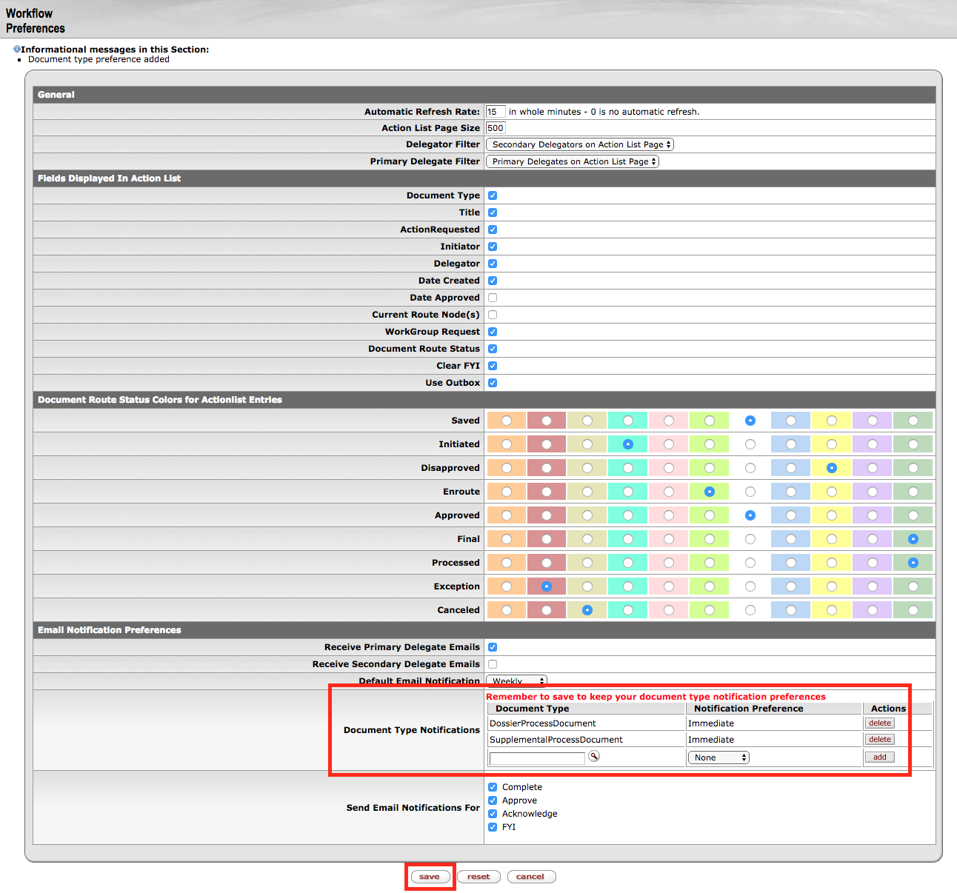

- Next make sure to click the “save” button at the bottom of the page to save your preferences.

